**ADS ASSIGNMENT 12**

Name : Shweta Kakade

PRN : 21510043  
Batch : T2

Firstly the spatial-master folder has been downloaded

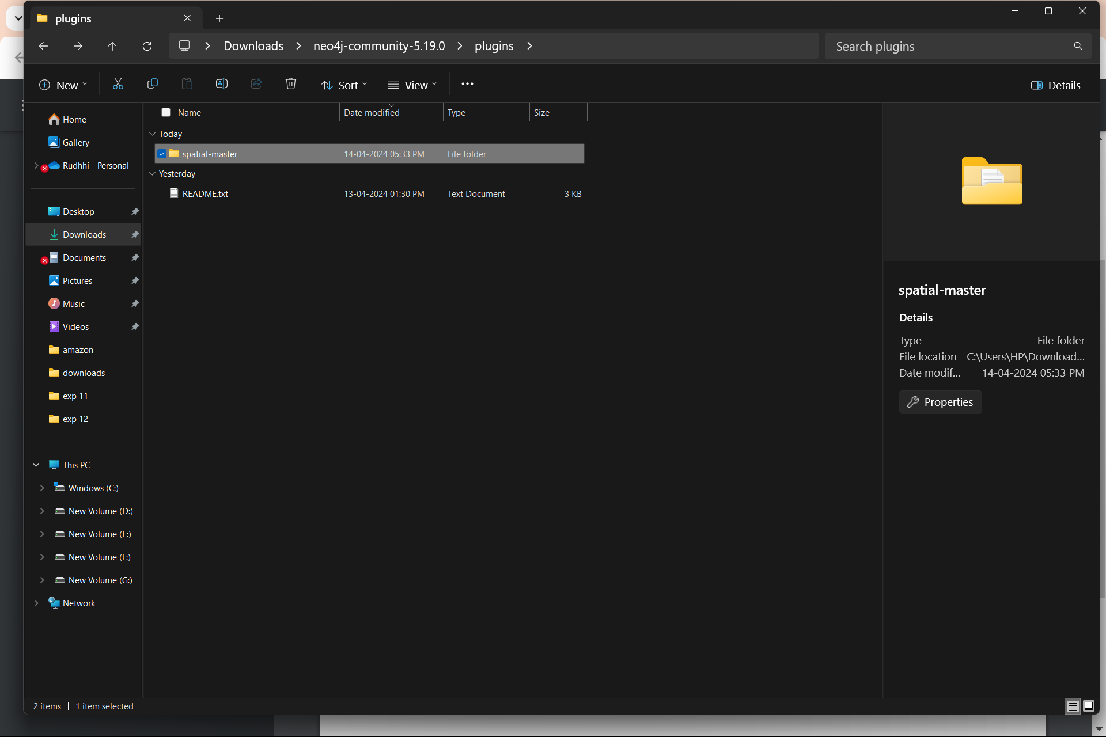

The below given is a dataset of **10,567 cities** with latitude and longitude.

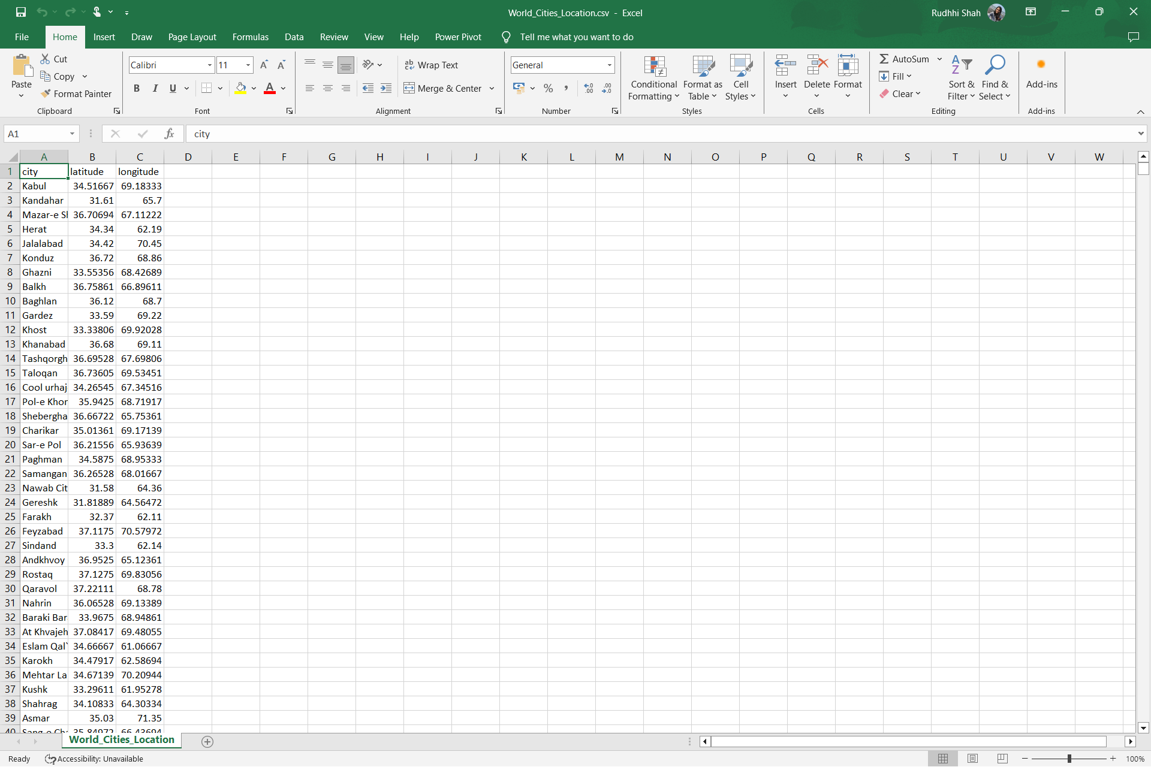

This csv is imported into neo4j

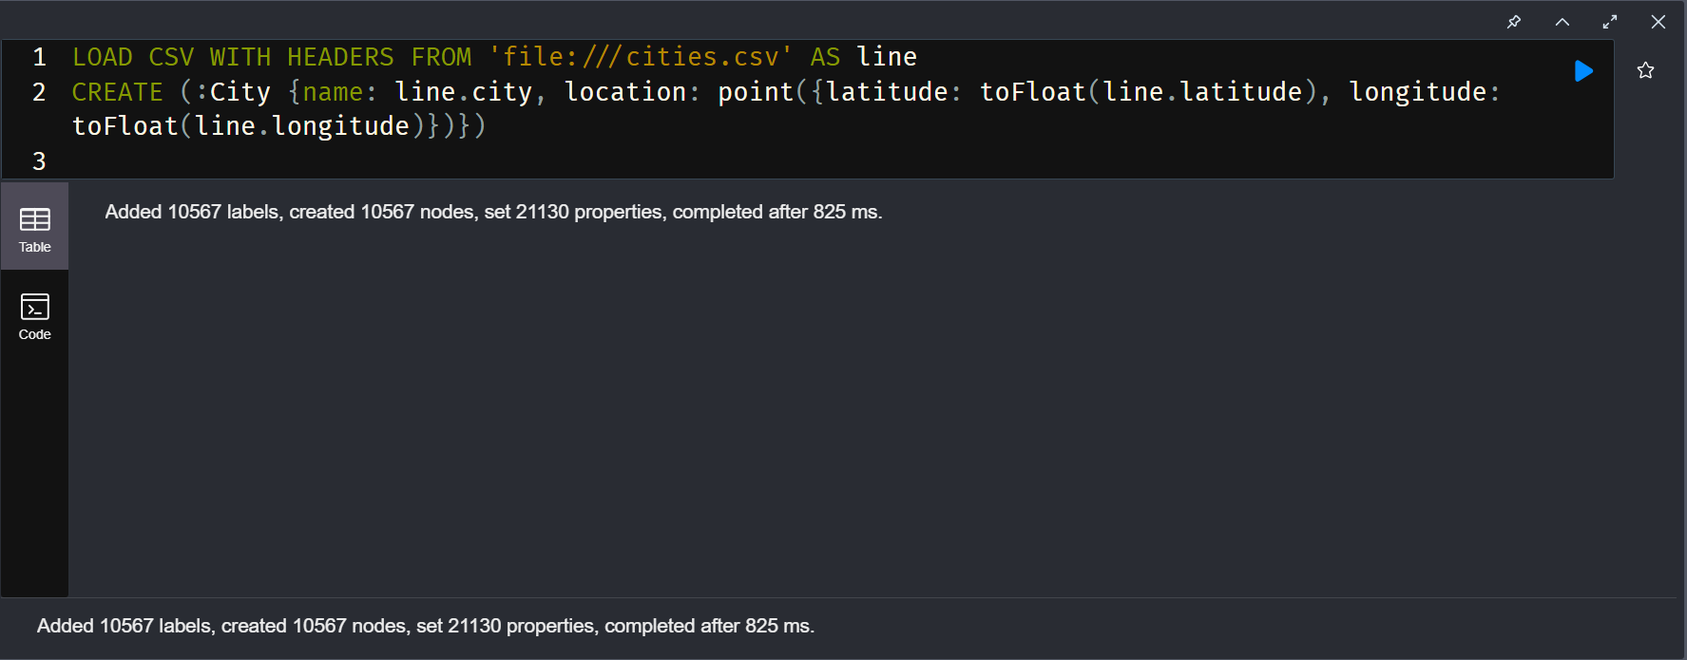

But note the data must be in the **import** library

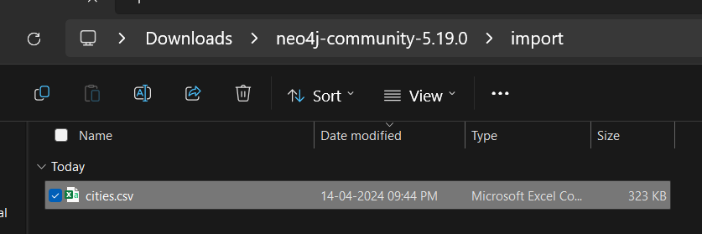

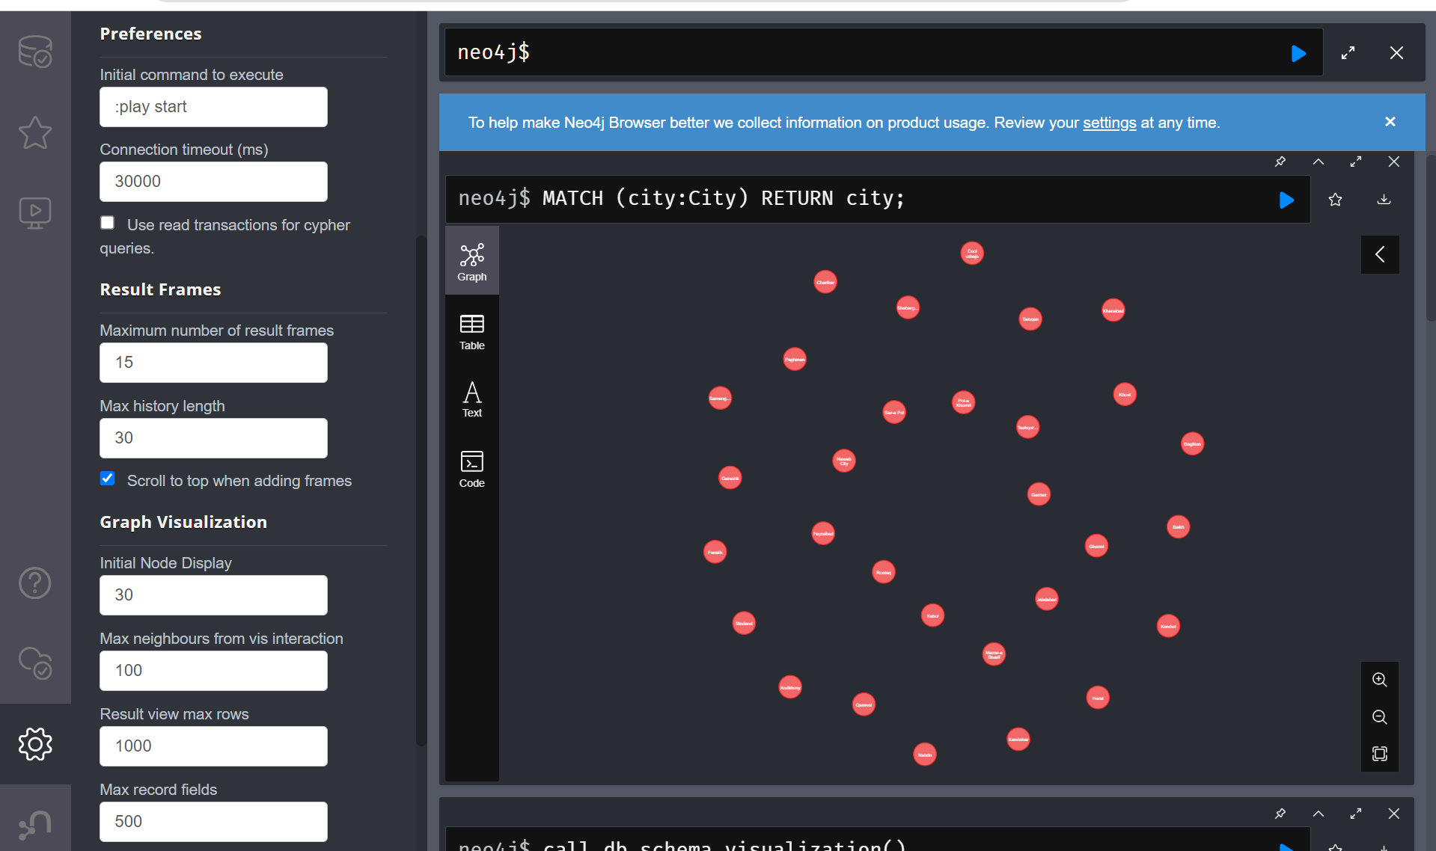



We can change the number of nodes visible through **Initial Node Display**

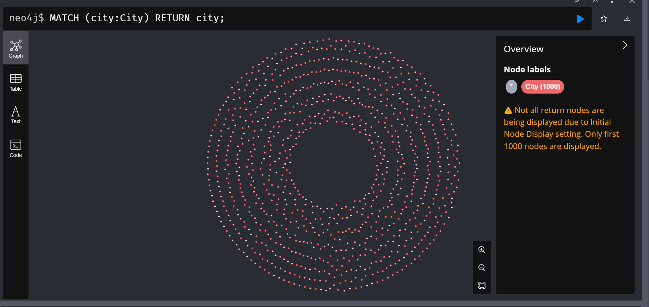

Distance between “Kabul” and “Konduz”

